Model: Fingerprint Lock CJ-6686
Installation Instruction:
Mortise Choice
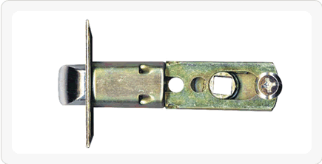
If needing 60mm latch,Please fix the screw to the picture
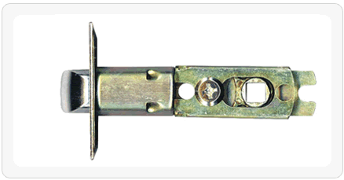
If needing 70mm latch,Please fix the screw to the picture
Hole Sketch
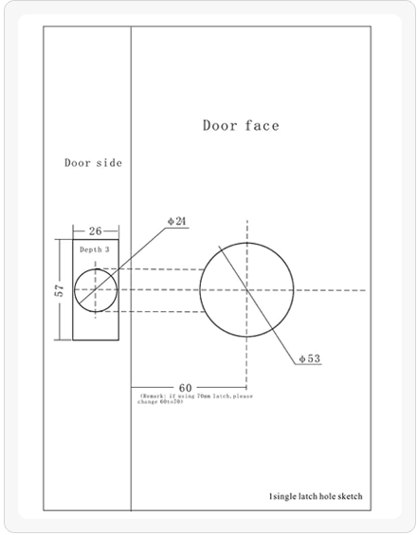
Installation Drawing
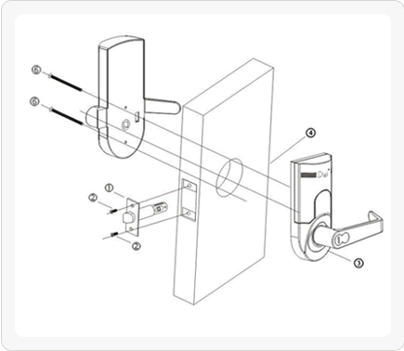
Dimension
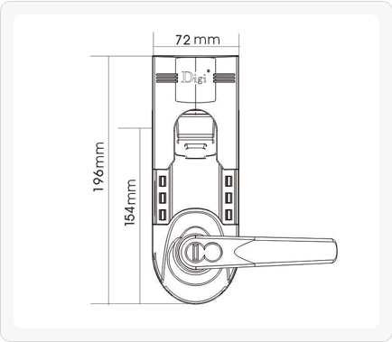
Technical Specifiation:
Item# | Description | Technical Parameters
1 | Sensor | Bright background,for totally resolving the issue of remaining fingerprints
2 | Resolution factor | 560 dpi
3 | Sensor resistance to destruction | 4H pencil 20cm constant impact for 1000 times resulting in no destruction
4 | Startup time | ＜1s
5 | Contrast | 1:N
6 | FRR | Less than or equal to 1%(≤1%)
7 | FAR | Less than or equal to 0.0001%(≤0.0001%)
8 | Angle of finger application | ±60°
9 | Fingerprint registration module | One time of registration producing one module
10 | Fingerprint update | Fully automatic update technology
11 | ingerprint template storage | Automatic storage of fingerprint template when batteries are changed
12 | Max figerprint capacity | 150 fingerprints
13 | Light interference | Protection against direct sunshine
14 | Collector | Hard glass,nano-treated surface,extremely resistant to friction
15 | Static power consumption | Less than 30uA
16 | Dynamic power consumption | Working current between 150-300mA
17 | Working voltage | Intemational standard batteries,4*1.5V alkaline batteries,DC6V
18 | Service life of batteries | For opening a door 15,000 times in nomal cases
19 | Power supply | Batteries,plus extemal power supply
20 | Password capacity | 78
21 | Spare voltage for working voltage | 9V
22 | Waming voltage | 4.8V
23 | Electrostatic resistance | ＞15000V
24 | Working temperature for fingerprint | -20℃～60℃
25 | Working temperature for keypad | -30℃～70℃
26 | Working humidity | 10%-97%
27 | Storage temperature | -30℃～70℃
28 | Password setting | Random combination
29 | password length | 8 digits
30 | Spare power supply for working voltage | 9V
31 | Area of collection | 18.2mm(L)X16mm(W)

